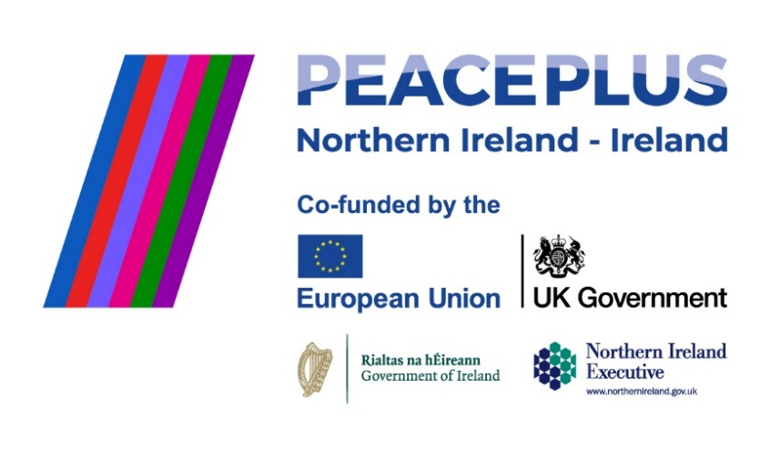
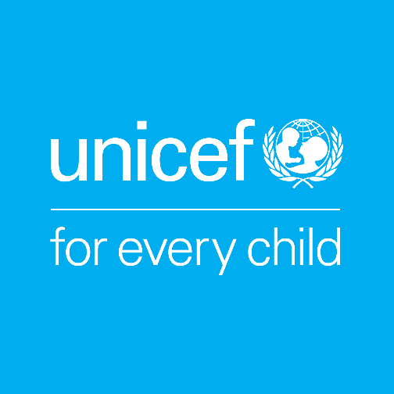

UNICEF works in some of the world’s toughest places, to reach the world’s most disadvantaged children. To save their lives. To defend their rights. To help them fulfil their potential. Across 190 countries and territories, we work for every child, everywhere, every day, to build a better world for everyone. UNICEF is the world’s largest children’s humanitarian organisation.

Job Title | Child Rights Education Officer
Reporting To | Head of Advocacy and Public Policy
Location | Border Counties (remote with travel across the region expected)
Hours | 3 days a week
Salary Range | Commensurate with experience
Duration | Fixed-term, 4 Year contract (supported by PEACEPLUS, a programme managed by the Special EU Programmes Body (SEUPB).

UNICEF Ireland’s Child Rights Education Programme is grounded in the UN Convention on the Rights of the Child (UNCRC). Through our Child Rights Schools programme we work with children, educators and school communities to build rights-respecting environments where children and adults learn about rights and children are empowered to make decisions about the things that affect them.
About the COLOUR Project
The COLOUR Project (Communities of Learning, Openness, and Understanding through Rights) is a four-year, cross-border and cross-community project supported by PEACEPLUS, a programme managed by the Special EU Programmes Body (SEUPB). The project is led by UNICEF Ireland in partnership with UNICEF UK, Kids’ Own Publishing Partnership, and Ulster University. Through a rights-based, creative, and collaborative approach, the project aims to bring together primary schools from both sides of the border to build positive relationships within and between communities.

Role Overview
The Child Rights Education Officer will play a crucial role in delivering the COLOUR project. Working closely with all project partners and especially UNICEF UK counterparts, the CRE officer will support school clusters as they progress through the Child Rights Schools programme through a cross-border, cross community partnership. Using child rights education, the Officer will work directly with educators, children and wider school communities to promote awareness of children’s rights, facilitate collaboration across borders and communities, and help create inclusive, rights-respecting environments.

Responsibilities

School & Cluster Support
- Support the establishment and progression of cross-border Child Rights Clusters, guiding participating schools through the CRS programme and its milestones.
- Build strong, trust-based relationships with principals, teachers, and school coordinators, offering tailored advice, mentoring, and practical support.
- Deliver or coordinate training and workshops for educators, building their capacity to embed rights-based practice in everyday school life.
- Facilitate and support child-led activities, enabling children to explore, understand, and advocate for their rights.
- Promote cross-community and cross-border collaboration, including joint initiatives, events, and shared learning across clusters.
- Monitor and record school progress in line with CRS programme criteria, ensuring timely updates and accurate documentation.
Collaboration & Programme Development
- Work closely with the wider project team—including researchers, creative partners, and other consortium members—to align activities and share learning across the project.
- Contribute to the development of high-quality, age-appropriate child rights resources for schools.
- Engage directly with teachers and students to test and refine resources, ensuring they are relevant and impactful.
- Contribute to project reporting, reflection, and evaluation, gathering feedback and identifying both success stories and challenges.

Operational & Team Support
- Adhere to and promote UNICEF Ireland’s safeguarding policies and procedures, ensuring all activities meet safeguarding and inclusion standards across all partners.
- Contribute to team and board updates, as well as international UNICEF thematic working groups.

Person Specification
Education:
- A degree in Education, Social Sciences, Community Development, Youth Work, or a related field. Equivalent professional experience will also be considered.

Essential Skills and Experience:
- Proven experience working directly with schools, educators, or community groups to deliver educational or rights-based programmes.
- Strong facilitation skills with the ability to engage both children and adults in participatory, inclusive learning.
- Excellent relationship-building skills and the ability to foster trust with diverse stakeholders.
- Demonstrated commitment to human rights, inclusion, equality, and intercultural understanding.
- Strong organisational and time-management skills, with the ability to meet deadlines and balance competing priorities.
- Excellent verbal and written communication skills.
- Competence in using ICT for programme delivery, communication, and monitoring (e.g., Microsoft Office, online learning tools).
- Experience working with safeguarding policies and procedures in education or community settings.
Desirable Skills and Experience:
- Knowledge of the primary education systems in both Ireland and Northern Ireland.
- Experience in cross-community or cross-border programmes.
- Experience in children’s rights education or rights-based approaches.
- Understanding of the PEACEPLUS programme or other EU-funded projects.
- Experience in resource development for educational or youth settings.
- Ability to adapt facilitation approaches to suit different contexts, age groups, and needs.
- Creative problem-solver with flexibility to adapt plans when needed.
Personal Attributes:
- Highly collaborative team player who is also able to work independently.
- Warm, respectful, and approachable, with a strong commitment to treating all individuals with dignity.
- Culturally sensitive and able to navigate different perspectives with tact and diplomacy.

Terms of Employment
This is a part-time (3 days per week), fixed-term contract for 4 years, aligned with the COLOUR Project’s funding from PEACEPLUS through 2029. The project operates primarily in the border region, so candidates based in the border counties are strongly preferred due to the high level of school and community engagement required. Candidates living in or near Dublin may also be considered, but should be aware that the role will require regular travel across the border area.

Expected start date: As soon as possible.

UNICEF Ireland is committed to adhering to the highest standards of child protection and child safeguarding. UNICEF reserves the right not to employ staff or engage volunteers or other representatives who are deemed to pose or potentially pose a risk to the protection of children, to the full extent permitted by law. Additionally, all candidates must sign UNICEF Ireland’s Child Protection Policy & Procedures before commencing employment, engaging as a volunteer, intern, consultant or representative of UNICEF Ireland.

To apply please submit your CV & a cover letter via email to:
Aibhlín O’Leary at aibhlin@unicef.ie by 5pm Wednesday 27th August 2025, with interviews to be scheduled promptly after the closing date.

