The articles in the Convention on the Rights of the Child are indivisible, meaning they are all important. However, some articles are more relevant for schools.

Consider how much is already being done in your school to support child rights. Write your answers below.

 | How are the identities of children respected in your school?
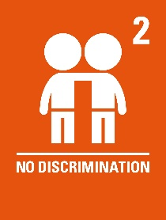 | What does your school have in place to ensure that all children are given equal opportunities?
 | How do you ensure that the decisions you make are in the best interests of the children in your school?
 | What strategies does your school have in place to ensure children have a say in what and how they learn?
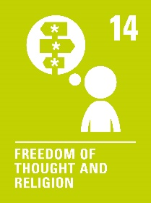 | How are children supported to express their thoughts freely (if respectful) in your school?
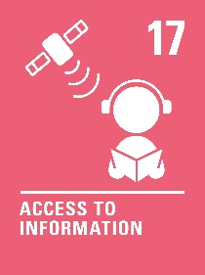 | What checks are in place to ensure the information the children are accessing in your school is reliable?
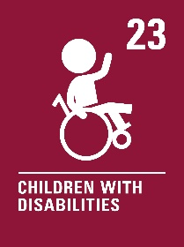 | What extra supports does your school have in place for children with disabilities?
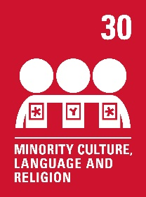 | How does your school respect children's diverse cultural backgrounds?
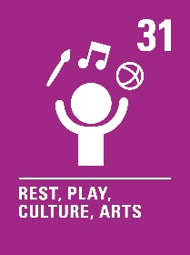 | How is time incorporated into the children's day for rest and play?

