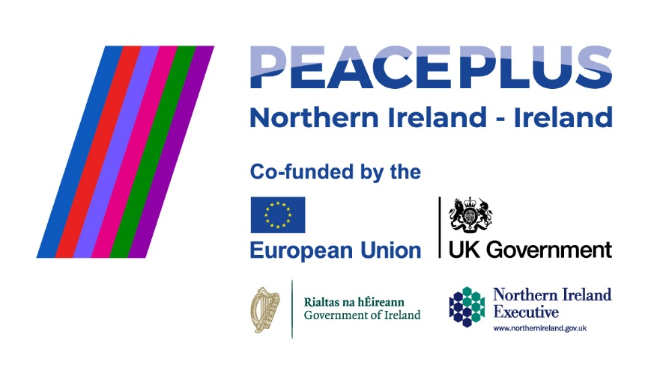
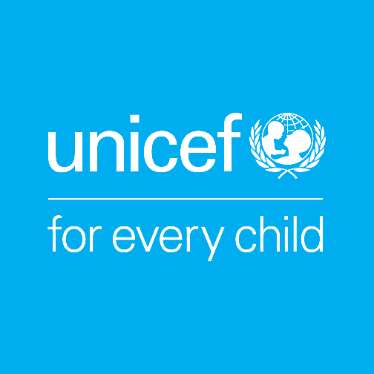

UNICEF works in some of the world’s toughest places, to reach the world’s most disadvantaged children. To save their lives. To defend their rights. To help them fulfil their potential. Across 190 countries and territories, we work for every child, everywhere, every day, to build a better world for everyone. UNICEF is the world’s largest children’s humanitarian organisation.

Job Title | COLOUR Project Coordinator
Reporting To | Head of Advocacy and Public Policy
Location | Preferably in the border region, though applicants based in/near Dublin will be considered.
Hours | 37.5 hours a week
Salary Range | €55,000 - €60,000
Duration | Fixed-term, 3 Year contract (supported by PEACEPLUS, a programme managed by the Special EU Programmes Body (SEUPB).

About the COLOUR Project
The COLOUR Project (Communities of Learning, Openness, and Understanding through Rights) is a four-year, cross-border and cross-community project supported by PEACEPLUS, a programme managed by the Special EU Programmes Body (SEUPB). The project is led by UNICEF Ireland in partnership with UNICEF UK, Kids’ Own Publishing Partnership, and Ulster University. Through a rights-based, creative, and collaborative approach, the project aims to bring together primary schools from both sides of the border to build positive relationships within and between communities.
Role Overview
We are seeking an experienced and highly organised Project Coordinator to play a central role in the successful delivery of the COLOUR Project, a cross-border initiative supported through the PEACEPLUS programme.
Employed by UNICEF Ireland as the lead partner, the postholder will act as the operational hub of the project, coordinating delivery across multiple consortium partners and ensuring compliance with PEACEPLUS funding requirements. The role combines project coordination, stakeholder management, reporting, governance and compliance responsibilities.
The successful candidate will work closely with UNICEF Ireland, UNICEF UK, Kids’ Own Publishing Partnership, Ulster University, and the Special EU Programmes Body (SEUPB) to ensure that project activities are delivered effectively, on time and in accordance with programme requirements.
This role is particularly suited to someone who is comfortable working in a complex, multi-partner environment and who has experience managing projects within regulated funding frameworks. While the role involves building positive relationships with a wide range of stakeholders, a significant aspect of the position involves coordinating reporting, procurement, communications, monitoring and compliance processes associated with PEACEPLUS funding.

Responsibilities

Project Coordination and Governance
• Coordinate the day-to-day management of the COLOUR Project across all work packages and partner organisations.
• Monitor progress against project plans, milestones, outputs and outcomes.
• Maintain project governance structures, including workplans, risk registers, action logs and decision records.
• Support effective project decision-making by ensuring timely information flow between partners and stakeholders.
Consortium and Stakeholder Management
• Act as the primary coordination point between consortium partners.
• Facilitate regular partner meetings, prepare agendas and minutes, and track agreed actions.
• Foster collaborative working relationships across the consortium and support alignment around shared project objectives.
• Represent the project at relevant meetings, events and stakeholder engagements.
Reporting, Compliance and PEACEPLUS Requirements
• Lead the coordination and preparation of narrative reports for the Special EU Programmes Body (SEUPB).
• Gather, review and consolidate reporting inputs from project partners.
• Support compliance with PEACEPLUS requirements relating to reporting, procurement, communications, monitoring, evaluation and horizontal principles.
• Maintain accurate project records and documentation to support audit and assurance processes.
• Ensure compliance with relevant organisational policies and legal requirements, including GDPR.
Financial Coordination
• Work closely with finance colleagues and partner organisations to support budget monitoring and financial reporting.
• Monitor expenditure against project budgets and support forecasting and reforecasting processes.
• Ensure expenditure and procurement processes align with funder requirements and organisational procedures.
Safeguarding, Inclusion and Quality Assurance
• Promote and uphold UNICEF Ireland’s safeguarding policies and procedures.
• Support partners to maintain safeguarding standards across all project activities.
• Monitor cross-cutting commitments relating to inclusion, equality and participation.
• Contribute to continuous learning and quality improvement across the project.

Person Specification
Essential Skills and Qualifications:
• Proven experience coordinating complex projects involving multiple stakeholders or partner organisations.
• Experience working within grant-funded, publicly funded, EU-funded or similarly regulated programmes.
• Strong understanding of project governance, reporting, compliance and risk management processes. Experience coordinating procurement, communications or compliance processes within funded programmes.
• Excellent organisational skills and ability to manage multiple priorities simultaneously.
• Strong written communication skills, including experience preparing reports for funders or senior stakeholders.
• Excellent interpersonal and stakeholder management skills.
• Ability to work independently, exercise sound judgement and solve problems proactively.
• Proficiency in Microsoft Office and project management tools
- Ability to travel regularly throughout the border region and across the island of Ireland as required by the role. A full driving licence and access to a car is therefore essential.

Highly Desirable Attributes and Skills:
• Experience of PEACE, PEACEPLUS, INTERREG or other complex EU-funded programmes.
• Knowledge of the education sector in Ireland and/or Northern Ireland.
• Experience of cross-border or cross-community initiatives.
Terms of Employment
This is a fixed-term contract for 3 years, aligned with the COLOUR Project’s funding from the SEUPB until August 2029. The project operates primarily in the border region, so ideally the role will be based within one of the border counties, with predominantly remote work and regular travel across the region. Alternatively, the role can be based at UNICEF Ireland’s Dublin office, where a hybrid working policy applies.

Expected start date: As soon as possible.

UNICEF Ireland is committed to adhering to the highest standards of child protection and child safeguarding. UNICEF reserves the right not to employ staff or engage volunteers or other representatives who are deemed to pose or potentially pose a risk to the protection of children, to the full extent permitted by law. Additionally, all candidates must sign UNICEF Ireland’s Child Protection Policy & Procedures before commencing employment, engaging as a volunteer, intern, consultant or representative of UNICEF Ireland.

To apply please submit your CV & a cover letter via email to:
Aibhlín O’Leary at aibhlin@unicef.ie by midnight Friday 10th July 2026, with interviews expected to take place in mid-July.

