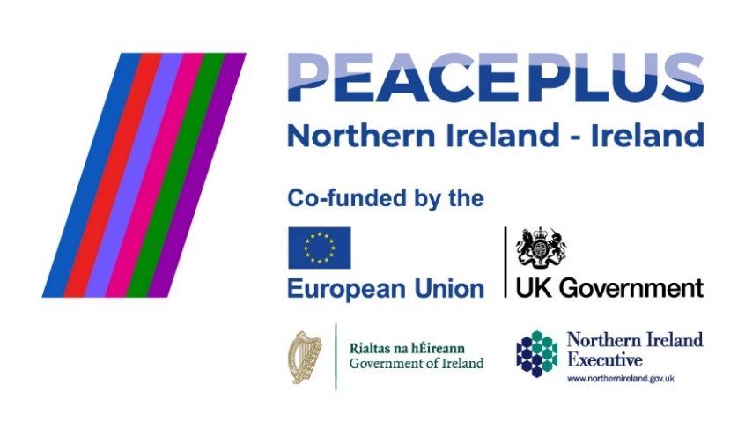
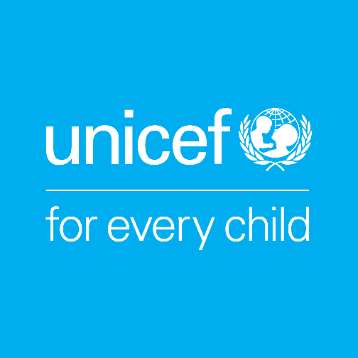

UNICEF works in some of the world’s toughest places, to reach the world’s most disadvantaged children. To save their lives. To defend their rights. To help them fulfil their potential. Across 190 countries and territories, we work for every child, everywhere, every day, to build a better world for everyone. UNICEF is the world’s largest children’s humanitarian organisation.

Job Title | Project Officer - COLOUR (Child Rights Education)
Reporting To | Head of Advocacy and Public Policy
Location | Border Counties (remote with travel across the region expected)
Hours | 3.5 days a week
Salary | € 45, 750 per annum (full-time equivalent). The salary for this 3.5-day (0.7 FTE) position is €32,025 per annum.
Duration | Fixed-term, 3 Year contract to end of August 2029 (supported by PEACEPLUS, a programme managed by the Special EU Programmes Body (SEUPB).

UNICEF Ireland’s Child Rights Education Programme is grounded in the UN Convention on the Rights of the Child (UNCRC). Through our Child Rights Schools programme we work with children, educators and school communities to build rights-respecting environments where children and adults learn about rights and children are empowered to make decisions about the things that affect them.
About the COLOUR Project
The COLOUR Project (Communities of Learning, Openness, and Understanding through Rights) is a four-year, cross-border and cross-community project supported by PEACEPLUS, a programme managed by the Special EU Programmes Body (SEUPB). The project is led by UNICEF Ireland in partnership with UNICEF UK, Kids’ Own Publishing Partnership, and Ulster University. Through a rights-based, creative, and collaborative approach, the project aims to bring together primary schools from both sides of the border to build positive relationships within and between communities.

Role Overview
The Project Officer - COLOUR (Child Rights Education) will play a central role in delivering the COLOUR Project across participating schools in Ireland. Working closely with UNICEF Ireland, UNICEF UK and the wider project partnership, the postholder will support schools as they progress through the Child Rights Schools programme, helping to establish cross-border Child Rights Clusters and build educators' capacity to embed children's rights in school life.
The role combines direct engagement with schools with programme coordination, resource development and collaborative working across the wider partnership. The successful candidate will build strong relationships with school communities, support educators to develop rights-respecting practice, facilitate meaningful participation by children, and contribute to the delivery of a unique cross-border initiative that promotes understanding, inclusion and positive relationships between communities.

Responsibilities

School & Cluster Support
- Support recruitment and onboarding of participating schools to the project.
- Support the establishment and progression of cross-border Child Rights Clusters, guiding participating schools through the CRS programme and its milestones.
- Build and maintain strong, trust-based relationships with principals, teachers and school coordinators, providing tailored advice, mentoring and practical support throughout their participation in the project.
- Deliver or coordinate training and workshops for educators, building their capacity to embed rights-based practice in everyday school life.
- Facilitate and support child-led activities, enabling children to explore, understand, and advocate for their rights.
- Promote cross-community and cross-border collaboration, including joint initiatives, events, and shared learning across clusters.
- Monitor and record school progress in line with CRS programme criteria, ensuring timely updates and accurate documentation.

Collaboration & Programme Development
- Work closely with UNICEF UK colleagues and the wider partnership to support consistent delivery of the Child Rights Schools programme across the border region.
- Work closely with the wider project team (including researchers, creative partners, and other consortium members) to align activities and share learning across the project.
- Contribute to the development of high-quality, age-appropriate child rights resources for schools.
- Engage directly with teachers and students to test and refine resources, ensuring they are relevant and impactful.
- Contribute to project reporting, reflection, and evaluation, gathering feedback and identifying both success stories and challenges.

Operational & Team Support
- Adhere to and promote UNICEF Ireland’s safeguarding policies and procedures, ensuring all activities meet safeguarding and inclusion standards across all partners.
- Contribute to project reporting, monitoring and evaluation activities, maintaining accurate records and supporting reporting requirements as required.
- Contribute to team and board updates, as well as international UNICEF thematic working groups.

Person Specification
Education:
- A degree in Education, Social Sciences, Community Development, Youth Work, or a related field. Equivalent professional experience will also be considered.

Essential Skills and Experience:
- Proven experience working directly with schools, educators, children, young people or community groups to deliver educational or rights-based programmes.
- Strong facilitation skills with the ability to engage both children and adults in participatory, inclusive learning.
- Excellent relationship-building skills and the ability to foster trust with diverse stakeholders.
- Demonstrated commitment to human rights, inclusion, equality, and intercultural understanding.
- Strong organisational and time-management skills, with the ability to meet deadlines and balance competing priorities.
- Excellent verbal and written communication skills.
- Competence in using ICT for programme delivery, communication, and monitoring (e.g., Microsoft Office, online learning tools).
- Experience working with safeguarding policies and procedures in education or community settings.
- A full driving licence and access to a car is essential as the role requires regular travel across the border region.

Desirable Skills and Experience:
- Knowledge of the primary education systems in both Ireland and Northern Ireland.
- Experience in cross-community or cross-border programmes.
- Experience in children’s rights education or rights-based approaches.
- Understanding of the PEACEPLUS programme or other EU-funded projects.
- Experience in resource development for educational or youth settings.
- Ability to adapt facilitation approaches to suit different contexts, age groups, and needs.
- Creative problem-solver with flexibility to adapt plans when needed.

Personal Attributes:
- Demonstrated ability to build trusted relationships with schools, educators and community partners.
- Excellent facilitation and communication skills.
- Ability to work independently across a geographically dispersed region.
- Flexible, collaborative and solution-focused approach to programme delivery.
- Warm, respectful and approachable, with a strong commitment to treating all individuals with dignity.
- Culturally sensitive and able to navigate different perspectives with tact and diplomacy

Terms of Employment
This is a part-time (3.5 days per week), fixed-term contract for 3 years, aligned with the COLOUR Project’s funding from PEACEPLUS through August 2029.

The project operates primarily across the border region. As the role involves frequent engagement with participating schools and communities, candidates based in the border counties, or within reasonable travelling distance of the border region, are strongly preferred. Applicants should be able to travel regularly throughout the region, and a full driving licence and access to a car are essential.

Expected start date: As soon as possible.

UNICEF Ireland is committed to adhering to the highest standards of child protection and child safeguarding. UNICEF reserves the right not to employ staff or engage volunteers or other representatives who are deemed to pose or potentially pose a risk to the protection of children, to the full extent permitted by law. Additionally, all candidates must sign UNICEF Ireland’s Child Protection Policy & Procedures before commencing employment, engaging as a volunteer, intern, consultant or representative of UNICEF Ireland.

To apply please submit your CV & a cover letter via email to:
Aibhlín O’Leary at aibhlin@unicef.ie by 5pm Wednesday 5th August 2026.

Please include "COLOUR Project Officer" in the subject line of your email. Interviews will be scheduled promptly after the closing date.

Please note that UNICEF Ireland is recruiting for two separate Child Rights Education roles. Applicants wishing to be considered for both positions should submit separate applications, clearly indicating the role(s) they wish to be considered for.

